1
- Title: Smart Medication Management: Enhancing Medication Adherence with an IoT-Based Pill Dispenser and Smart Cup
- Authors: Vinay Peddisetti, Pavan Kumar Kandregula, Joel Anil John, Suseela Poomdla, Kiran George, Anand Panangadan
- DOI: 10.1109/AIMHC59811.2024.00032
- Most important information:
  - Particularly relevant because it’s the only paper I had that explicitly tries to move beyond simple pill-box opening detection toward consumption verification
  - Combines three components: smart pill dispenser + smart cup + Android application
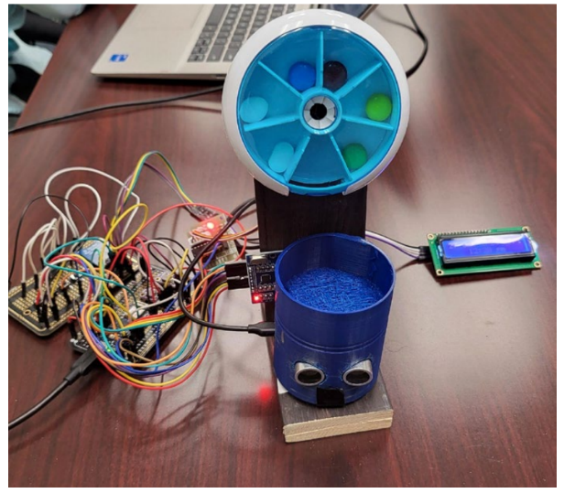
  - Dispensing: an Arduino Nano RP2040 controls the dispenser. When requested, a stepper motor rotates a seven-slot pill container to dispense the scheduled medication into the smart cup. An RFID mechanism is used to verify that the smart cup is correctly positioned before dispensing. BLE communication between dispenser and cup confirms that the pill has been delivered.
  - Intake verification: the smart cup contains an LSM6DSOX accelerometer and gyroscope. Motion/orientation information from these sensors is combined to infer whether the user performed the characteristic cup movement associated with taking the medication. An ultrasonic sensor is also used to detect user proximity following dispensing
  - Besides from usual reminders, the Android application also sends a notification when medication is running low
- Limitations:
  - Consumption is inferred indirectly from cup movement, so the system still cannot unequivocally prove that the pill entered the mouth and was swallowed
  - BLE may constrain connectivity/compatibility
  - Pills still require manual loading
7
- Title: Smart Medical Pills Dispenser
- Authors: Khawla A. Alnajjar, Abdulaziz Altamimi, Khalifa Altamimi, Ahmed Alshehhi, Sam Ansari, Soliman Mahmoud, Abir Jaafar Hussain
- DOI: 10.1109/DeSE60595.2023.10468851
- Most important information:
  - Working prototype based on Arduino Mega + ESP8266, with Wi-Fi connectivity and a smartphone application
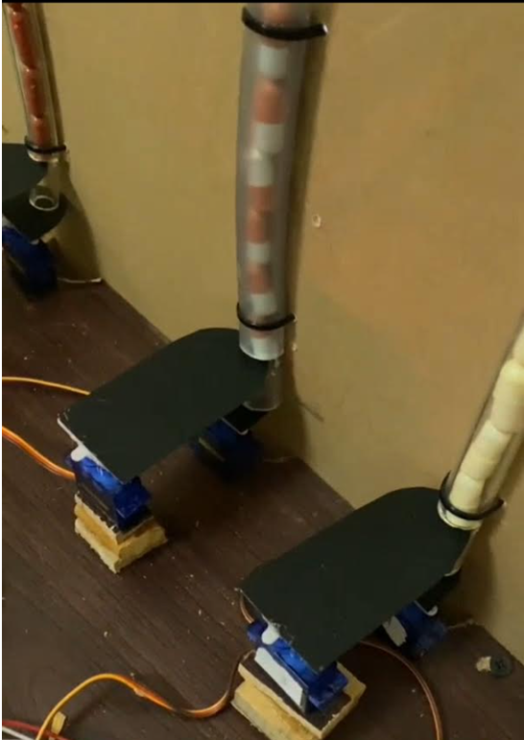
  - Dispensing: four separate pill tubes are used, one for each medication type. Each tube uses servo motors to isolate and release one pill at a time into a drawer. A photoelectric proximity sensor is used to compare the number of dispensed pills with the predetermined required quantity
  - Intake verification: a reed switch detects opening/movement of the collection drawer. Opening the drawer is timestamped and interpreted by the system as pill retrieval/intake; if the dose is not retrieved, a phone notification is issued within 10 minutes
  - Bench testing showed very good mechanical dispensing performance: 0% dispensing error for larger pills, while error for small pills was reduced from roughly 6% to 1% after modifying tube geometry
- Limitations:
  - The main weakness is that drawer opening is treated as equivalent to medication intake. It proves that the user accessed the pills, not that they swallowed them (and anyway, they did no validation of the intake-detection mechanism in terms of false positives/false negatives)
  - Dispensing performance depends on pill dimensions and geometry
  - No meaningful real-user or elderly-user evaluation was performed
  - Manual refilling is still required
10
- Title: Project Pill Tracker: An Advanced and Automated Pill Tracking & Dispenser
- Author: Archishma Marrapu
- DOI: 10.1109/ISEC61299.2024.10664768
- Most important information:
  - Arduino-based smart dispenser integrated with an Android application/web interface, LEDs, LCD, buzzer and user button.
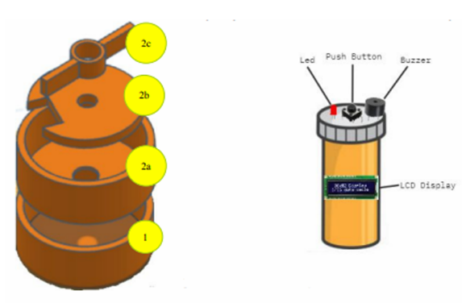
  - Dispensing: when the user requests medication, the controller first checks the medication schedule; then, a servo motor rotates the pill storage mechanism until the appropriate opening aligns with the output. Pills then fall through the dispensing hole into the collection area, and an ultrasonic sensor counts the pills passing through the outlet. Dispensing stops when the required dose count has been reached.

  - Intake verification: none.
  - Interesting functions include QR-code/manual medication registration, refill notifications and caregiver-linked accounts.
  - The system obtained approximately 91% weighted functionality in the extraction data, with dispensing around 90% and pill-management/reminder functions around 93%.
- Limitations:
  - Main limitation is that there is no real intake verification
  - Limited compatibility with different pill dimensions/types
  - Manual refilling
12
- Title: A Smart Pill Reminder with Configurable Alerts, Multi-Modal Notifications, and Integrated Health Monitoring for Medical Adherence
- Authors: Chandana Mohanty, Saranya S., Carolina Jennifer S., Remya Raj
- DOI: 10.36548/jismac.2025.2.002
- Most important information:
  - Uses an ESP32 and Arduino Nano
  - Dispensing: there is no automatic dispensing mechanism, pills are stored in manually accessible drawers/compartments
  - Intake verification: none
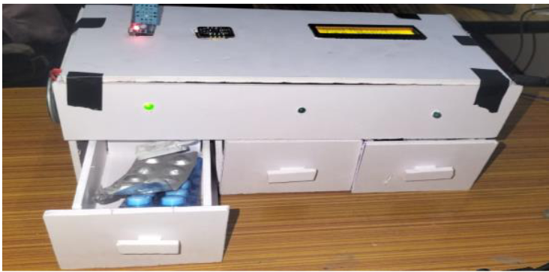
  - Interesting that it integrates DHT11 temperature/humidity sensing, allowing monitoring of environmental conditions relevant to medication storage/degradation; also integrates a MAX30102 sensor for heart rate and SpO₂, extending the pillbox into a basic physiological-monitoring platform
  - Only paper I had that was tested on real users (for about one week, with 10 participants aged 50+)
- Limitations:
  - No automatic pill dispensing and no pill-removal or ingestion verification
  - Manual pill refilling
9
- Title: Development of Smart Pill Expert System Based on IoT
- Authors: P. Dayananda and Amrutha G. Upadhya
- DOI: 10.1007/s40031-023-00956-2
- Most important information:
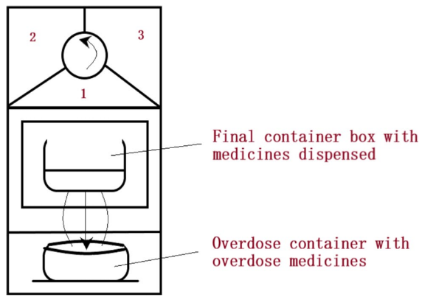
  - Dispensing: medication is stored in a rotating medication housing. At the scheduled time, the required compartment is moved into alignment with an opening; the medication then falls by gravity into a collection box.
  - Interesting feature: a DC-motor-controlled mechanism is also used for overdose management, redirects excess pills to a separate container
  - Intake verification: an IR obstacle sensor detects whether medication has been removed from the final collection box
  - The prototype reported approximately 90% overall functionality/accuracy
- Limitations:
  - Removal from the collection box is again used as a proxy for intake; the authors explicitly acknowledge that the system can’t determine whether the patient actually swallowed the medication
  - The reported accuracy/functionality evaluation is not very clearly defined, particularly regarding pickup-detection accuracy and false detections
  - Manual refilling
5
- Title: A Smart Pill Container for Improved Medication
- Authors: A. A., E. E. S., N. R.
- Only interesting features:
  - Use Machine Learning for therapy management / drug recommendation, rather than for controlling the dispensing mechanism or detecting actual pill ingestion.
  - The same system also contains face-recognition functionality
- Relevant limitation:
  - The paper does not appear to provide enough detail in the extraction on the input features, training dataset, train/test split, Random Forest parameters, validation method or prediction accuracy can skip this if we’re tight on space, but might be interesting if we want to include ML at some level

